Name: ​
​
C# Variables: Knowledge Check
​
The Box Analogy​

 | Think of a variable as a storage box in the computer's memory. To use it, you need to know exactly what kind of thing fits inside the box, and what you are going to call the box so you can find it later.  ​  Q. In C#, you must define two things before you can put anything into a variable box. What are they?
​
The Big Three Data Types
​
Q. Label each image with the correct C# data type that it best represents and briefly write what that data type is used to store.

Word bank:
1. int 2. string 3. double

 | 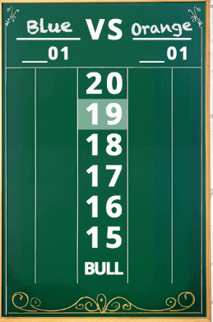 | 
​

Q. Why does C# force us to declare data types like 'int' instead of just treating everything as a 'string'?

​
Making Programs Interactive
​
Choose the correct option for each question. Highlight or circle your answer.
​
Q. Which command is used to output text so it appears on the screen?

a) Console.Text() | b) Console.WriteLine() | c) Console.ReadLine() | d) Screen.Print()
​
Q. Which command pauses the program to wait for the user to type something and press enter?

a) Console.WriteLine() | b) User.Input() | c) Console.Wait() | d) Console.ReadLine()
​
Q. The Console.ReadLine() command always captures and returns data as which data type (even if the user types a number)?

a) string | b) int | c) double | d) text
​
​
Q. Complete the summary below by filling in the blanks with the correct terms from the word bank. Each term should be used once.

Word bank: declaration, double, int, memory, string, variable

A __________ is a named location in the computer's memory used to store data.
When you create a variable, you are allocating space in the computer's _________.
Specifying the name and the data type for a new variable is known as __________.
To store a whole number like 25, you should use the __________ data type.
If you need to store a decimal value like 19.99, the __________ data type is required.
Any data captured from a user via Console.ReadLine() is treated as a __________.

